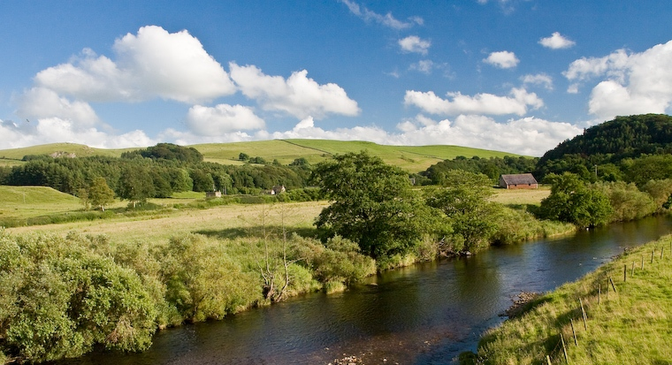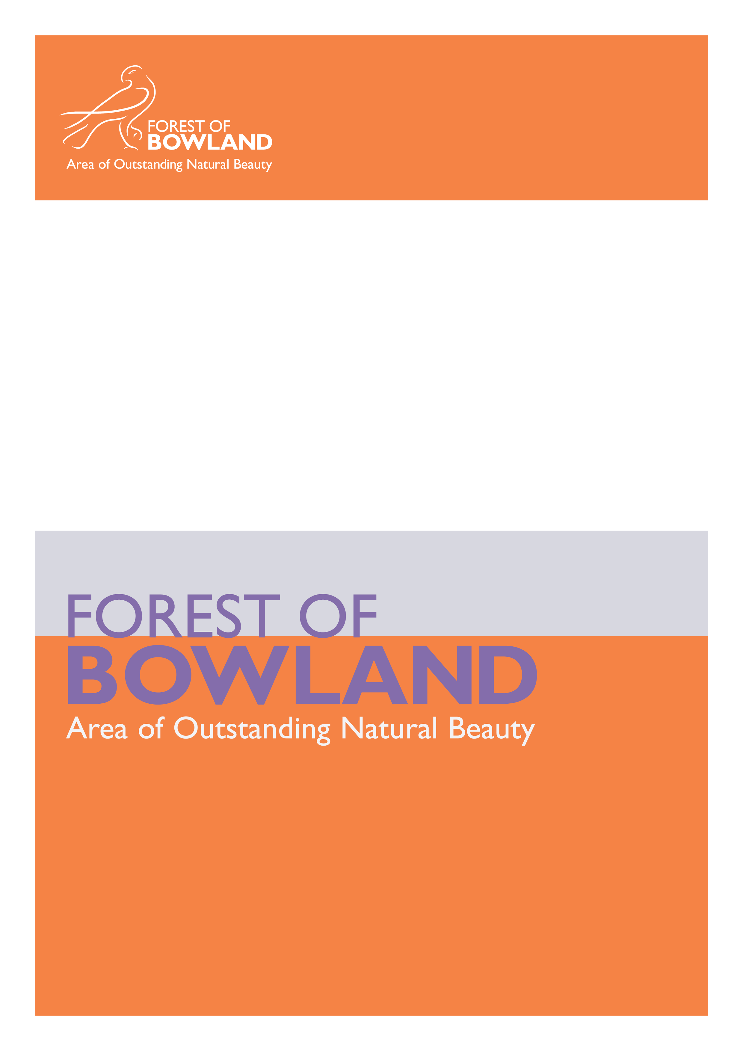
Appendix 'A'
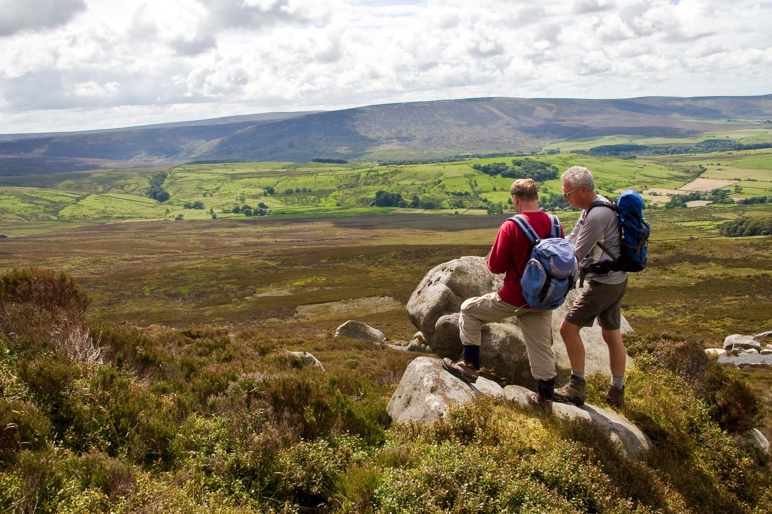

AONB Unit Business Plan 2011-2014
AONB Unit Business Plan 2011- 2014
AONB Unit
October 2011

Introduction

The Forest of Bowland Area of Outstanding Natural Beauty (AONB) is one of England’s finest landscapes and is internationally important for its heather moorland, blanket bog and rare birds. The special qualities of the area which contribute to its distinctive 'sense of place' can be summarised as:

- Wild open spaces
- A special place for wildlife
- A landscape rich in heritage
- A living landscape
- Delicious local food and drink
- A place to enjoy and keep special

The AONB designation means that the area should not only be conserved and enhanced, but also that recreation and sustainable development should be promoted to help to sustain the landscape and its communities.

The AONB Partnership and Unit

The AONB is managed by a partnership of landowners, farmers, voluntary organisations, wildlife groups, recreation groups, local councils and government agencies, who work to protect, conserve and enhance the natural and cultural heritage of this special area.

The AONB Unit is the staff team, who are employed on behalf of the AONB Partnership, to prepare and implement the statutory AONB Management Plan. The team currently comprises six members (4.3 full-time equivalents), with additional support from two LCC Environmental Project Officers (formerly Countryside Officers).

A Plan for the Future

This business plan sets out how the AONB Unit will contribute to the work of the Partnership in achieving the long-term vision for the AONB:

'...the Forest of Bowland retains its sense of local distinctiveness, notably the large-scale open moorland character of the Bowland Fells, traditional buildings and settlement patterns of villages, hamlets and farmsteads. Natural and cultural resources are sympathetically managed and contribute to a sustainable and vibrant local economy. The management of the Forest of Bowland AONB has improved the quality of the landscape for all stakeholders.'

The AONB Unit is working towards four key outcomes:

- An outstanding landscape of natural and cultural heritage
- Resilient and sustainable communities
- A strong connection between people and the landscape
- A dynamic and effective AONB partnership

The Business Plan

This plan will guide the work of the AONB Unit from 2011 - 2014. The actions within it link directly to the implementation of the statutory AONB Management Plan and links are shown against each action. It is designed to be a rolling 3-year plan, which will be reviewed and updated annually.

The AONB Unit aims to work with the following values at the core of its operation:

- We are knowledgeable and passionate about the AONB - its landscape, biodiversity and culture
- We care about the environment and sustainability
- We work together with others to achieve success
- We value people and are approachable and responsive
- We communicate clearly and effectively

It should also be recognised that this plan relies on the work of other partner organisations, communities and individuals to achieve the successful delivery of the AONB Management Plan and the long-term vision for the area.

Strategic Priorities 2011 - 2014
An outstanding landscape of natural and cultural heritage | Resilient and sustainable rural communities | A strong connection between people and the landscape | A dynamic and effective AONB Partnership
OL1 Provide advice, training and support to promote sustainable land management practices; helping to safeguard the natural and cultural landscape of the AONB.  OL2 Continue a strategic programme of restoration and re-establishment of traditional boundaries (e.g. hedgerows, dry stone walls, railing fences); allied to provision of training opportunities to promote skills associated with these traditional boundaries.  OL3 Work in partnership to facilitate and promote the management and restoration of priority habitats within the AONB; in particular those habitats identified as more vulnerable within the AONB Climate Change Adaptation Plan.  OL4 Work with others, in particular local authorities, to establish development management and other policies/strategies, which result in positive outcomes for the landscape quality of the AONB. | SC1 Continue to support and develop local parish lengthsman schemes within the AONB to assist in the management and maintenance of key community assets.  SC2 Support and promote local businesses and products to maintain their viability.  SC3 Continue to promote and manage the Sustainable Development Fund; whilst also responding to local community requests for advice on funding, project management and volunteering.  SC4 Continue to develop, support and promote local tourism businesses; building on the AONB's reputation as an internationally-recognised destination for sustainable tourism. | PL1 Develop, improve, and promote access and recreational opportunities for a diverse range of people.  PL2 Provide high quality information, communications and events to enable people to enjoy and understand the landscape of the AONB and the work of the AONB Partnership.  PL3 Support local communities and visitors to conserve, restore, enjoy and learn about the heritage of the AONB, and develop programmes of activity which provide opportunities to engage people with the landscape. | AP1 Work with others to maximise the successful delivery of the AONB Management Plan and effectively monitor progress.  AP2 Achieve excellence in the governance and management of the AONB Partnership and Unit, its people and resources; and helping to identify sustainable future funding to support these.

AONB Unit - Staff Leads
CH – Cathy Hopley, Development and Funding Officer
EL – Elliott Lorimer, Principal AONB Officer
HB – Hetty Byrne, Sustainable Tourism & Web Development Officer
MP – Mike Pugh, Business Development Officer
NO – Nick Osborne, Site Access & AONB Manager
SS – Sandra Silk, Project Officer

Lancashire County Council Environmental Projects - Staff Leads
DP – Dave Padley, Environmental Projects Officer (Area East)
TW – Tarja Wilson, Environmental Projects Officer (Area North)

An outstanding landscape of natural and cultural heritage (OL)
Authors Name Authors Title
Date
OL1 Provide advice, training and support to promote sustainable land management practices; helping to safeguard the natural and cultural landscape of the AONB
We will: | 2011/12 | 2012/13 | 2013/14 | AONB Mgmt. Plan Links | Staff lead(s)
OL1.1 Provide advice and guidance to land managers on appropriate woodland management and planting within the AONB landscape | On-going | On-going | On-going | 4.1B, 4.3A | DP/TW
OL1.2 Support traditional woodland management skills |  | 1 traditional woodland management skills course held | 1 traditional woodland management skills course held | 4.1B, 4.3A | DP/TW
OL1.3 Encourage and support woodland extension, creation and management |  | England Woodland Grant Scheme training held | England Woodland Grant Scheme training held | 3.2E, 4.1B, 4.1D, 4.2A, 4.3A | DP/TW
OL1.4 Encourage the return of semi-improved rough pasture to grass moorland and upland heath | Regular meetings with NE HLS Advisors | Regular meetings with NE HLS Advisors | Regular meetings with NE HLS Advisors | 2.2B | DP/TW
OL1.5 Encourage the conservation and enhancement of wet flushes, mires and wet acid grassland | Regular meetings with NE HLS advisors | Regular meetings with NE HLS advisors | Regular meetings with NE HLS advisors | 2.2C | DP/TW
OL1.6 Develop design guidance notes for riverside and moorland fencing |  | Draft guidance notes developed | Guidance notes published | 2.3B, 2.3E | DP/EL
OL1.7 Strengthen working relationships with key stakeholders for river catchment management (e.g. Environment Agency, United Utilities and River and Catchment Trusts) to encourage sensitive management of riverbank habitats for biodiversity and landscape. | Initial liaison meeting established | Regular liaison meetings held | Regular liaison meetings held | 5.1A, 5.2A | EL/DP
OL2 Continue a strategic programme of restoration and re-establishment of traditional boundaries (e.g. hedgerows, dry stone walls, railing fences); allied to provision training opportunities to promote skills associated with these traditional boundaries.
We will: | 2011/12 | 2012/13 | 2013/14 | AONB Mgmt. Plan Links | Staff lead(s)
OL2.1 Deliver an annual programme of traditional boundaries projects | 6 projects delivered | 6 projects delivered | 6 projects delivered | 1.2H, 1.4J, 2.4B, 3.2C, 4.1A | DP/TW
OL2.2 Promote training opportunities in hedge-laying and walling (including schools and vocational training) | 2 training opportunities promoted | 2 training opportunities promoted | 2 training opportunities promoted | 13.1B | DP/TW
OL2.3 Develop and promote hedge-laying and walling competitions | 1 event held | 1 event held | 1 event held | 13.1B | DP/TW
OL2.4 Respond to community desire to restore roadside railings | As requests are received | As requests are received | As requests are received | 14.2A | DP/TW

OL3 Work in partnership to facilitate and promote the management and restoration of priority habitats within the AONB; in particular those habitats identified as more vulnerable in the AONB Climate Adaptation Plan
We will: | 2011/12 | 2012/13 | 2013/14 | AONB Mgmt. Plan Links | Staff lead(s)
OL3.1 Carry out research and mapping to identify the extent of peat and blanket bog in the AONB, and the location/extent of restoration projects | Attend Lancashire Peat Partnership (LPP) meetings  Work with LPP to develop AONB plan for conserving and enhancing blanket bog, including collection of monitoring data | Attend LPP meetings  Monitor and update data | Attend LPP meetings  Monitor and update data | 2.1A | CH/TW
OL3.2 Encourage the restoration of areas of exposed and eroded peat and the conservation and restoration of blanket bog and mosaic of moorland dwarf shrub species | Regular meetings with NE HLS advisors and landowners | Regular meetings with NE HLS advisors  and landowners | Regular meetings with NE HLS advisors  and landowners | 2.2A, 2.1C, 2.1D | DP/TW
OL3.3 Encourage good practice in upland heather burning and alternatives; helping to develop a fire prevention strategy and fire plans for the area | Farmer and landowner group discussion  held | If required, establish an AONB-wide fire operations group |  | 2.2B, 2,2H | NO/DP/  TW
OL3.4 Co-ordinate volunteer and professional surveys to identify and monitor species-rich grassland within the AONB | Volunteers identified and survey method established | Volunteers trained and carrying out surveys | Volunteers trained and carrying out surveys | 3.1A | CH
OL3.5 Identify potential project sites for species-rich grassland creation and enhancement; leading to the development of projects to conserve and enhance this priority habitat, alongside community engagement and education activities | Meeting with key partners held and potential project sites identified | 1 project delivered | 2 projects delivered | 3.1A | CH
OL4 Work with others, in particular the local authorities, to establish development management and other policies/strategies, which result in positive outcomes for the landscape quality of the AONB
We will: | 2011/12 | 2012/13 | 2013/14 | AONB Mgmt. Plan Links | Staff lead(s)
OL4.1 Provide appropriate advice, support and formal responses to development proposals and consultations on policies/strategies that will affect the AONB and its setting (in particular planning applications, LDF consultations and other local, regional and national strategies) | Appropriate responses provided | Appropriate responses provided | Appropriate responses provided | 1.1A, 1.1F, 2.3D, 5.3C, 12.3A, 12.3C, 12.3D, 12,4A, 12.4D, 19.3B | EL
OL4.2 Continue a programme of undergrounding of power lines in the AONB with Electricity Northwest | Priority projects list drawn up and projects developed | 1 project delivered | 1 project delivered | 12.3D | EL/DP/TW
OL 4.3 Develop an AONB design guide (based on the Landscape Character Assessment) to ensure development is in keeping with and conserves or enhances landscape character (i.e. in terms of appropriate materials, form, setting, scale etc) | Research best practice  Establish working group | Outline design guide produced  Partner consultation held | AONB design guide published  Awareness- raising event(s) held | 1.4K, 3.2G, 8.1F, 9.5A, 12.1A, 12.1D | EL/CH

OL4.4 Liaise with local authority planning officers on relevant AONB planning concerns (landscape character, wind energy, tourism business development) | Periodic meetings held | Periodic meetings held | Periodic meetings held | 12.3B, 12.4C | EL

Resilient and sustainable rural communities (SC)
Authors Name Authors Title
Date
SC1 Continue to support and develop local parish lengthsman schemes within the AONB to assist in the management and maintenance of key community assets
We will: | 2011/12 | 2012/13 | 2013/14 | AONB Mgmt. Plan Links | Staff lead(s)
SC1.1 Support Parish Councils to continue to fund and manage existing lengthsman schemes | AONB policy on future of PL schemes agreed | AONB service level agreements developed and agreed with Parish Councils |  | 8.1E, 10.1C, 16.1C | TW/DP
SC1.2 Prepare an evaluation report on existing parish lengthsman schemes in the AONB | Evaluation completed |  | Evaluation completed | 8.1E, 10.1C, 16.1C | TW
SC1.3 Work with Parish Councils to develop best practice (e.g. record-keeping) to help demonstrate best value | Timesheet template developed and distributed to PL schemes |  |  | 8.1E, 10.1C, 16.1C | TW/DP
SC1.4 Contribute to the development of new pilot schemes being created by Lancashire County Council | Attend meetings and respond to pilot evaluation, where appropriate |  |  | 8.1E, 10.1C, 16.1C | TW/DP

SC2 Support and promote local businesses and products to maintain their viability
We will: | 2011/12 | 2012/13 | 2013/14 | AONB Mgmt. Plan Links | Staff lead(s)
SC2.1 Support local businesses, via provision of advice, signposting, training (e.g. access for all, business skills, sense of place), networking opportunities and events | One-to-one advice provided  2 training events provided  2 business-led events held | One-to-one advice provided  2 training events provided  2 business-led events held | One-to-one advice provided  2 training events provided  2 business-led events held | 6.2D, 10.1B, 10.2A, 11.2A, 11.2B, 17.1A, 19.3D | MP
SC2.2 Continue to provide support for Bowland Experience Ltd. (BEx) | BEx board meetings held  Provision of information- sharing opportunities for BEx members  BEx promotional items developed  Secure place on AONB JAC for BEx | BEx board meetings held  Provision of information- sharing opportunities for BEx members | BEx board meetings held  Provision of information- sharing opportunities for BEx members | 7.6E | MP
SC2.3 Support the transfer of member of the Sustainable Tourism Network (STN) to BEx | Transfer of members commenced  Closure of the STN |  |  | 10.2A | MP
SC2.4 Continue to support the development, management and promotion of the Bowland Tourism Environment Fund (BTEF) | Investigate feasibility of 'Gift Aid' for BTEF | Develop 'Gift Aid' for BTEF |  | 16.2B | MP
SC2.5 Support business 'cluster' development within the AONB (as part of Lancashire Green Tourism Project) | 2 business clusters supported |  |  | 7.1B | MP
SC3 Continue to promote and manage the Sustainable Development Fund; whilst also responding to local community requests for advice on funding, project management and volunteering
We will: | 2011/12 | 2012/13 | 2013/14 | AONB Mgmt. Plan Links | Staff lead(s)
SC3.1 Manage the Sustainable Development Fund (SDF) to support appropriate, small-scale projects within the AONB, aiming to increase 'match-funding' from external sources; whilst seeking to promote the fund and individual projects and good practice. | SDF panel meetings held  All SDF funds committed  Funded projects complete and return monitoring information, as required  SDF Annual Report  produced | SDF panel meetings held  All SDF funds committed  Funded projects complete and return monitoring information, as required  SDF Annual Report  produced | SDF panel meetings held  All SDF funds committed  Funded projects complete and return monitoring information, as required  SDF Annual Report  produced | 14.2D, 19.1G | CH
SC3.2 Provide support to communities seeking project development and funding advice and assistance (e.g. projects to improve provision of rural services, renewable energy projects and local community events) | 10 community groups advised/supported | 10 community groups advised/supported | 10 community groups advised/supported | 11.1A, 11.3A, 14.4A, 16.2C, 19.3C | SS/CH
SC4 Continue to develop, support and promote local tourism businesses; building on the AONB's reputation as an internationally-recognised destination for sustainable tourism
We will: | 2011/12 | 2012/13 | 2013/14 | AONB Mgmt. Plan Links | Staff lead(s)
SC4.1 Promote the strong 'brand identity' for AONB visitors, working closely with tourism organisations, visitor information centres, businesses and gateway towns | Sense of Place materials used in variety of formats (e.g. website, exhibition panels, pop-up banners) | Sense of Place materials used in variety of formats (e.g. website, exhibition panels, pop-up banners) | Sense of Place materials used in variety of formats (e.g. website, exhibition panels, pop-up banners) | 6.2D, 6.3B, 18.4J | HB
SC4.2 Complete the Lancashire Green Tourism Project and continue to support GTBS with tourism businesses in the AONB | Project completed on time and budget  Project evaluation report produced (including mapping)  2 routes downloads from GTBS businesses produced | Business advisory visits made  6 GTBS accreditations achieved within AONB and 2km buffer  2 route downloads from GTBS businesses produced | Business advisory visits made  6 GTBS accreditations achieved within AONB and 2km buffer  2 route downloads from GTBS businesses produced | 3.1F, 19.3D | HB
SC4.3 Continue to support and develop appropriate elements of the European Charter for Sustainable Tourism, including support to Charter partners, the Sustainable Tourism Forum, networking within Europarc (particularly within the Atlantic Isles section) | Produce ST partner logo and usage guide  Attend EAI/Europarc meetings, as appropriate | ST Forum held  Attend EAI/Europarc meetings, as appropriate | ST Forum held  Attend EAI/Europarc meetings, as appropriate | 7.6B, 7.6I | HB/MP
SC4.4 Carry out evaluation and monitoring of visitor and tourism enterprise information, in particular visitor pressure, patterns and future markets (including occupancy and satisfaction data) | Visitor survey carried out  Business enterprise survey carried out | Business enterprise survey carried out | Visitor survey carried out  Business enterprise survey carried out  Profile of future tourism markets completed | 8.3B, 8.3C, 18.3B, 18.3C, 18.3D | HB
SC4.5 Deliver familiarisation visits and study tours for tourism businesses and organisations | GTBS familiarisation visit held | 'Access for all' familiarisation visit held | One familiarisation  visit held | 19.1D | HB
SC4.6 Promote and share good practice of the AONB, as a lead partnership in supporting sustainable tourism within Europe's protected areas | Plan EUROPARC Atlantic Isles Seminar on Sustainable Tourism | Hold EUROPARC Atlantic Isles Seminar on Sustainable Tourism  Plan Sustainable Tourism Study Tour with EUROPARC partners | Hold Sustainable Tourism Study Tour | 9.6D, 18.4B, 18.4C, 18.4G, 18.4J | CH/HB
SC4.7 Continue to promote local produce and farming | Manage and update local produce database  Support and attend Clitheroe Food Festival | Manage and update local produce database  Review AONB future involvement in local food festivals | Manage and update local produce database | 6.6D, 6.9D, 10.2C | HB

A strong connection between people and the landscape (PL)
Authors Name Authors Title
Date
PL1 Develop, improve and promote access and recreational opportunities for a diverse range of people
We will: | 2011/12 | 2012/13 | 2013/14 | AONB Mgmt. Plan Links | Staff lead(s)
PL1.1 Work in partnership with key stakeholders to improve access in the wider countryside of the AONB; including support for implementation of PRoW Improvement Plans | Regular meetings of Access and Recreation Working Group held | Regular meetings of Access and Recreation Working Group held | Regular meetings of Access and Recreation Working Group held | 8.1B, 8.1C, 8.1N, 8.1D, 8.1P, 8.2A, 8.3A | NO/TW/DP
PL1.2 Carry out a review of existing AONB promoted routes | Review and completed and acted upon (e.g. some routes no longer promoted) | Review and completed and acted upon | Review and completed and acted upon | 6.6G, 8.1J | NO/TW/DP
PL1.3 Develop new promoted routes at Barley and Halton gateway |  | Routes developed at each gatweway |  | 7.1G, 8.1H, 8.1L | TW/DP
PL1.4 Develop bridleway links between Gisburn Forest and Settle (Pennine Bridleway National Trail), for North Lancs Bridleway Phase 2 sections and Whitendale bridleway network | Commence landowner negotiations | Development of route and funding strategy | Commence construction of first sections of bridleway | 8.1L | TW/DP
PL1.5 Develop 'tramper' access projects | 2 projects delivered | 2 projects delivered | 2 projects delivered | 8.1H, 8.2A | TW/DP

PL1.6 Co-ordinate delivery of Fiendsdale erosion control project | Project commenced | Project completed |  | 2.1B, 2.1C, 2.1D | TW
PL1.7 Review effectiveness and data from pedestrian counters on PRoW |  | Review completed and acted upon |  | 8.1A, 8.1C | TW/DP
PL1.8 Ensure use of appropriate PRoW signposts in the AONB | Discussions held with LCC & PBC PRoW teams | Guidance note and agreement in place |  | 8.1F, 8.1P | NO/TW/DP
PL2 Provide high quality information, communications and events to enable people to enjoy and understand the landscape of the AONB and the work of the AONB partnership
We will: | 2011/12 | 2012/13 | 2013/14 | AONB Mgmt. Plan Links | Staff lead(s)
PL2.1 Co-ordinate and review Festival Bowland (FB) | Co-ordinate FB Steering Group  Evaluation of customer feedback completed (via incentivised postcard scheme)  Annual review of aims and content of FB completed and acted upon | Co-ordinate FB Steering Group  Evaluation of customer feedback completed (via incentivised postcard scheme)  Annual review of aims and content of FB completed and acted upon | Co-ordinate FB Steering Group  Evaluation of customer feedback completed (via incentivised postcard scheme)  Annual review of aims and content of FB completed and acted upon | 7.1A | SS
PL2.2 Publicise Festival Bowland effectively | FB brochure produced  Monthly FB events posters produced and distributed  6 press releases/year produced to promote FB events  Create Google calendar for FB events | FB brochure produced  Monthly FB events posters produced and distributed  6 press releases/year produced to promote FB events  Update Google calendar with FB events | FB brochure produced  Monthly FB events posters produced and distributed  6 press releases/year produced to promote FB events  Update Google calendar with FB events | 6.5A | SS
PL2.3 Support and promote external events that help to deliver AONB objectives | Maintain LOIS database for partner-led events | Maintain LOIS database for partner-led events | Maintain LOIS database for partner-led events | 6.5B | HB
PL2.4 Management and implementation of the Forest of Bowland AONB brand and graphic standards | Branding guidelines and templates for promotional materials produced  Annual review of leaflet stock completed, with option to update and print, where appropriate  Periodic review of AONB promotional materials against environmental standards  Photography competition held to update stock of AONB images | Training on branding guidelines for partner organisations and businesses (e.g BEx)  Annual review of leaflet stock completed, with option to update and print, where appropriate  Periodic review of AONB promotional materials against environmental standards | Annual review of leaflet stock completed, with option to update and print, where appropriate  Periodic review of AONB promotional materials against environmental standards | 6.1A, 6.1B, 6.2A, 6.4A, 6.4D, 6.8B, 14.2E | HB/SS
PL2.5 Encourage display of AONB website and information in Tourist Information Centres (TICs) and other public venues |  | Suitable TICs with touch-screen facilities identified | AONB information included on touch-screen facilities | 6.7B | HB/SS
PL2.6 Update and replace AONB boundary signs at key visitor 'gateways' to the AONB | 6 boundary signs replaced | 4 boundary signs replaced | 4 boundary signs replaced | 16.1C | DP/EL
PL2.7 Maintain Brochurelink service | Periodic review of Brochurelink reports carried out | Periodic review of Brochurelink reports carried out | Periodic review of Brochurelink reports carried out | 6.3C | HB
PL2.8 Regularly review and update the content of AONB website, in line with AONB Management Plan objectives and actions | Periodic review and update of route downloads completed  3 educational farm profiles developed  Protocol for inclusion of private enterprises on the AONB website written  Website data analysis completed and disseminated  Update of website maps completed | Periodic review and update of route downloads completed  3 educational farm profiles developed  Family activities webpage produced  Website data analysis completed and disseminated | Periodic review and update of route downloads completed  Website data analysis completed and disseminated | 6.4C, 6.6A, 6.6B, 6.6C, 6.6H | HB
PL2.9 Review design of AONB website |  | Web design support contracted  New web designs completed |  | 6.4C, 6.6A, 6.6B, 6.6C, 6.6H | HB
PL2.10 Research good practice in use of emerging technology to help interpret and promote the AONB | Investigate use of social media, podcasting, mobile apps and geo-caching to promote AONB information and events | GPS downloads generated for 10 walking routes  Investigate the potential to introduce audio trails for promoted routes | GPS downloads generated for all walking routes  Audio trails produced for promoted routes | 6.7A | HB
PL2.11 Source and promote newsworthy stories that promote the AONB and work of the partnership | Quarterly e-bulletin produced and promoted  Contacts maintained within local, regional and national media  4 AONB press releases per year produced | Quarterly e-bulletin produced and promoted  Contacts maintained within local, regional and national media  4 AONB press releases per year produced | Quarterly e-bulletin produced and promoted  Contacts maintained within local, regional and national media  4 AONB press releases per year produced | 6.10C, 14.1C, 18.4A, 18.4F | HB/SS

PL3 Support local communities and visitors to conserve, restore, enjoy and learn about the heritage of the AONB; and develop programmes of activity which provide opportunities to engage people with the landscape
We will: | 2011/12 | 2012/13 | 2013/14 | AONB Mgmt. Plan Links | Staff lead(s)
PL3.1 Support communities in developing cultural heritage projects of particular local importance or distinctiveness | 4 projects delivered | 4 projects delivered | 4 projects delivered | 1.4, 14.2A, 13.1B, 14.2B | CH/SS
PL3.2 Identify funds and partners to help deliver AONB-wide programmes of activity to research, conserve, enhance and interpret the landscape heritage of the AONB | Develop an HLF bid for 'Deerparks' (in conjunction with LCC Designed Landscape Project)  Develop young person's arts programme | Delivery of 'Deerparks' project  Deliver young person's arts programme  Develop HLF bid for AONB 50th anniversary project | Delivery of 'Deerparks' project  Commence delivery of AONB 50th anniversary project | 1.4, 2.4D, 6.9A, 7.1I, 13.1B | CH/SS

A dynamic and effective AONB partnership (AP)
AP1 Work with others to maximise the successful delivery of the AONB Management Plan and effectively monitor progress
We will: | 2011/12 | 2012/13 | 2013/14 | AONB Mgmt. Plan Links | Staff lead(s)
AP1.1 Participate in a range of fora and networks to represent AONB interests | On-going | On-going | On-going | 2.2L, 6.9C, 10.2B, 14.1C, 17.1E | All
AP1.2 Review the AONB Management Plan, in accordance with national guidance |  | Review and consultation commenced | Consultation held  SEA/AA completed  Review completed |  | EL
AP1.3 Ensure effective and inclusive consultation is carried out on all major AONB strategies and activity | On-going | On-going | On-going | 14.1A, 15.1 | EL
AP1.4 Manage and promote the interactive management plan (IMP) to ensure regular updating by partners | IMP updated by Unit and partners | IMP updated by Unit and partners | IMP updated by Unit and partners | 17.1E, 18.1B | HB
AP1.5 Produce a clear and concise AONB Annual Report | Annual Report produced | Annual Report produced | Annual Report produced | 18.4H | SS
AP1.6 Produce quarterly progress reports on business plan delivery | Quarterly reports produced | Quarterly reports produced | Quarterly reports produced | 17.1C | EL
AP1.7 Work with, and support National Association for AONBs (NAAONB) and other protected areas to share best practice and strengthen the status of AONBs locally and nationally | NAAONB events attended  Responses made to information and consultation requests, where appropriate | NAAONB events attended  Responses made to information and consultation requests, where appropriate | NAAONB events attended  Responses made to information and consultation requests, where appropriate | 18.4B | All
AP1.8 Support and maintain co-ordinated delivery of services and projects in the AONB in partnership with local authority countryside and environmental projects teams | LCC Env Projects staff attend AONB team meetings, where appropriate  Periodic meetings held with local authority and United Utilities countryside staff | LCC Env Projects staff attend AONB team meetings, where appropriate  Periodic meetings held with local authority and United Utilities countryside staff | LCC Env Projects staff attend AONB team meetings, where appropriate  Periodic meetings held with local authority and United Utilities countryside staff | 14.2C, 15.1, 17.1G | EL/NO
AP2 Achieve excellence in governance and management of the AONB Partnership and Unit, its people and resources; and helping to identify sustainable future funding to support these.
We will: | 2011/12 | 2012/13 | 2013/14 | AONB Mgmt. Plan Links | Staff lead(s)
AP2.1Ensure effective and productive functioning of AONB Joint Advisory Committee and its working groups, with agreed terms of reference | 2 JAC meetings, 3 to 4 funders group and regular working group meetings held | 2 JAC meetings, 3 to 4 funders group and regular working group meetings held | 2 JAC meetings, 3 to 4 funders group and regular working group meetings held | 15.1A, 15.1B, 15.1D | EL
AP2.2 Hold regular meetings and correspondence with AONB funding partners to ensure AONB Partnership and Unit are delivering against partners' key corporate objectives | Funders group meeting re-established | Regular funders group meetings held | Regular funders group meetings held | 16.1F | EL
AP2.3 Continue to support and work with NAAONB (as part of the tri-partite agreement with Defra and Natural England) to lobby for retention of secure, long-term funding arrangements for AONBs | NAAONB meetings, seminars and conferences attended, where appropriate | NAAONB meetings, seminars and conferences attended, where appropriate | NAAONB meetings, seminars and conferences attended, where appropriate | 16.1A | EL/NO
AP2.4 Ensure that a formal 'Memorandum of Agreement' (MoA) is in place between Defra and AONB partners | 4-year MoA signed and adopted by all AONB partners |  |  | 16.1F | NO/EL
AP2.5 Review audit of potential future funding opportunities for the AONB (commenced in late 2010/11) | Audit reviewed and acted upon |  |  | 16.1B | CH/EL
AP2.6 Develop a fund-raising strategy for the AONB partnership, investigating closer working with neighbouring protected areas (e.g Arnside and Silverdale AONB) on strategic funding bids | Investigate alternative forms of governance to assist in fund-raising (Friends of, Trusts etc)  Discussions held with neighbouring protected areas | Review AONB governance structure held  Fund-raising strategy action plan completed and commenced  Joint AONB funding bids developed, if appropriate | Fund-raising strategy and action plan delivered | 15.1A, 16.2A | CH/EL
AP2.7 Aim for excellence in management of the AONB Unit | Productive fortnightly team meetings, 1:1 meetings, employee PDRs and team building activities carried out | Productive fortnightly team meetings, 1:1 meetings, employee PDRs and team building activities carried out | Productive fortnightly team meetings, 1:1 meetings, employee PDRs and team building activities carried out | 15.2A | NO/EL
AP2.8 Provide structured training opportunities to AONB Unit and representatives | Staff training identified and attended | Staff training identified and attended | Staff training identified and attended | 15.2C | NO/EL
AP2.9 Annually review and update three-year AONB Unit business plan | Annual review and update completed | Annual review and update completed | Annual review and update completed | 15.2B, 17.1C | EL
AP2.10 Promote good practice in project management (incorporating best value, monitoring and evaluation, sustainability and involving volunteers) | Staff training identified and attended.  Project management guidelines developed, where appropriate | Staff training identified and attended.  Project management guidelines developed, where appropriate | Staff training identified and attended.  Project management guidelines developed, where appropriate | 17.1F, 18.1C, 18.1D | NO/EL
AP2.11 Implement AONB Unit environmental policy and action plan | Carbon reduction targets met | Carbon reduction targets met  Solar PV installed at AONB office | Carbon reduction targets met | 19.1J | CH

